
FREEZE GUARD:AN AI-DRIVEN INTELLIGENT FRAMEWORK FOR
REAL-TIME APPLICATION FREEZE DETECTION, ROOT CAUSE ANALYSIS AND AUTOMATIC RECOVERY SYSTEM

A CAPSTONE PROJECT REPORT

A Capstone Project Report submitted in partial fulfilment of the requirements for the Course of

CSA0405- OPERATION SYSTEMS

to the award of the degree of

BACHELOR OF ENGINEERING / BACHELOR OF TECHNOLOGY
IN
COMPUTER SCIENCE AND ENGINEERING
(BRANCH)

Submitted by
N DIMPLE BLOSSOM (192411227)

Under the Supervision of

Dr. Priskilla Angel Rani J

SIMATS ENGINEERING
Saveetha Institute of Medical and Technical Sciences
Chennai-602105

SEPTEMBER 2026

BONAFIDE CERTIFICATE

This is to certify that the Capstone Project entitled “Freeze Guard:An AI-Driven Intelligent Framework for Real-Time Application Freeze Detection, Root Cause Analysis and Automatic Recovery System” has been carried out by N DIMPLE BLOSSOM (192411227) under the supervision of Dr. Priskilla Angel Rani J and is submitted in partial fulfilment of the requirements for the current semester of the B.Tech Computer Science and Engineeering program at Saveetha Institute of Medical and Technical Sciences, Chennai.

COURSE COORDINATOR COURSE FACULTY

Dr Anasuya, Dr. Priskilla Angel Rani J,

Professor Professor

CSE Neural Networks SIMATS Engineering, SIMATS Engineering,
SIMATS, Chennai – 602105. SIMATS, Chennai – 602105.

DECLARATION

We, N DIMPLE BLOSSOM (192411227), K KEERTHANA SAI (192425143), S BHAGYA SHREE (192521338), V VYSHNAVI (192511056), B JANANI (192521052) of the CSE, SIMATS Engineering, Saveetha Institute of Medical and Technical Sciences, Chennai, hereby declare that the Capstone Project Work entitled “Freeze Guard:An AI-Driven Intelligent Framework for Real-Time Application Freeze Detection, Root Cause Analysis and Automatic Recovery System” is the result of our own bonafide efforts. To the best of our knowledge, the work presented herein is original, accurate, and has been carried out in accordance with the principles of engineering ethics and academic integrity. All sources, references, data, and other materials used in the project have been appropriately acknowledged. We further declare that the data, results, analysis, and findings presented in this report have not been fabricated, falsified, or manipulated. Any external tools, software, datasets, computational resources, or AI-assisted tools used during the project have been appropriately disclosed. We confirm that all applicable ethical, academic, institutional, and professional requirements have been duly followed throughout the planning, execution, analysis, and documentation of the project.

Place:
Date:

Signature of the Students with Names

Individual Contribution Statement
(Mandatory for all team projects)

Student  Name /  Register No. | Specific Responsibilities | Design &  Development Contribution | Testing &  Analysis  Contribution | Report Contribution | Approx.  Contribution  (%)
Student  1 | [Mention assigned  responsibilities] | [Design/devel opment work] | [Testing/anal ysis work] | [Sections contributed] | [__%]
Student  2 | [Mention assigned  responsibilities] | [Design/devel opment work] | [Testing/anal ysis work] | [Sections contributed] | [__%]
Student  3 | [Mention assigned  responsibilities] | [Design/devel opment work] | [Testing/anal ysis work] | [Sections contributed] | [__%]
Student  4 | [Mention assigned  responsibilities] | [Design/devel opment work] | [Testing/anal ysis work] | [Sections contributed] | [__%]
Total |  |  |  |  | 100%

ABSTRACT

Maximum approximately 300–400 words.

ABSTRACT
Application freezes are a common problem that can interrupt normal operation, reduce system reliability, and require manual intervention. Existing freeze detection methods may identify unresponsive applications but often provide limited information about the actual cause and recovery process. FreezeGuard is proposed as an AI-driven intelligent framework for real-time application freeze detection, root cause analysis, and automatic recovery. The proposed system continuously monitors application runtime behaviour to detect freeze conditions. When a freeze is identified, relevant runtime information is collected and analysed using an AI-based cause analysis module to determine the probable reason for the freeze. Based on the analysis, the automatic recovery module performs a suitable recovery action. The system follows a modular architecture consisting of freeze detection, AI-based cause analysis, and automatic recovery.
Testing focuses on detection response, AI-based cause identification, recovery behaviour, system reliability, and monitoring overhead. The results demonstrate the feasibility of integrating real-time freeze detection with intelligent cause analysis and automated recovery. FreezeGuard therefore provides a systematic approach for reducing manual intervention and improving the reliability and availability of applications.
Keywords: Application Freeze Detection, Artificial Intelligence, Root Cause Analysis, Runtime Monitoring, Automatic Recovery, Machine Learning

TABLE OF CONTENTS

Sl.  No | Title | Page  No
i | CERTIFICATE FROM THE SUPERVISOR | ii
ii | DECLARATION BY THE CANDIDATE | iii
Iii | INDIVIDUAL CONTRIBUTION STATEMENT | iv
iv | ABSTRACT | v
v | LIST OF FIGURES | vi
vi | LIST OF TABLES | vii
vii | LIST OF ABBREVIATIONS | viii
1 | CHAPTER 1: Introduction | 10-14
2 | CHAPTER 2: Literature Review | 15-19
3 | CHAPTER 3: Engineering Design & Trade-offs, Sustainability,  Ethics, Safety, Risk & Security | 20-25
4 | CHAPTER 4: Implementation, Testing & Results, Project  Management | 26-28
5 | CHAPTER 5: Conclusion & Reflection | 29-30
 | References
 | Appendices

LIST OF FIGURES
Figure No. | Figure Name | Page No.
Figure 1.1 | Application Freeze Problem | 10
Figure 3.1 | FreezeGuard System Architecture | 21
Figure 3.2 | FreezeGuard Workflow | 22
Figure 4.1 | FreezeGuard Performance Results | 27

LIST OF FIGURES MENAS GIVE FROM 1.1 TO 5.4
LIST OF TABLES
Table No. | Table Name | Page No.
Table 1 | Stakeholder/User Requirements | 20
Table 2 | Functional and Non-Functional Requirements | 20
Table 3 | Constraints and Applicable Standards | 21
Table 4 | Design Specifications | 21
Table 5 | Alternative Solutions Evaluation | 21
Table 6 | Trade-off Analysis | 22
Table 7 | Sustainability, Ethics, Safety, Risk and Security | 23
Table 8 | Risk Register | 25
Table 9 | Software Implementation and Modern Tools | 26
Table 10 | Test Plan and Verification | 26
Table 11 | Results and Performance Evaluation | 27
Table 12 | Project Planning, Roles and Budget | 28

LIST OF ABBREVIATIONS / SYMBOLS

Symbol | Description | Unit
AI | Artificial Intelligence | —
CPU | Central Processing Unit | %
RAM | Random Access Memory | MB
RCA | Root Cause Analysis | —
ML | Machine Learning | —

CHAPTER 1
INTRODUCTION AND ENGINEERING PROBLEM
  - Background
Modern software applications are expected to operate continuously and respond to user interactions in real time. However, applications may occasionally become unresponsive or enter a frozen state due to excessive resource utilisation, internal execution problems, resource contention, unexpected runtime conditions, or other system-level factors. An application freeze can interrupt user activities, reduce system reliability, and in critical applications may result in significant operational impact.
Conventional application monitoring systems primarily focus on detecting whether an application is running or not responding. Although freeze detection is important, identifying the occurrence of a freeze alone does not provide sufficient information for selecting an appropriate corrective action. Different freeze conditions may have different underlying causes, and applying the same recovery operation to every situation may not provide an efficient solution.
To address this limitation, the proposed FreezeGuard: An AI-Driven Intelligent Framework for Real-Time Application Freeze Detection, Root Cause Analysis and Automatic Recovery System integrates real-time freeze detection with intelligent cause analysis and automated recovery. The framework is designed to continuously observe application behaviour, identify freeze conditions, analyse the probable cause using AI, and provide the corresponding information to an automatic recovery mechanism.
The proposed system follows a modular approach consisting of freeze detection, AI-based freeze cause analysis, and automatic recovery. Among these components, the Freeze Cause Analysis module provides the intelligence required to understand the condition responsible for an observed application freeze.

1.2 Need for the Project
Application freezes are difficult to handle efficiently when monitoring systems only indicate that an application has become unresponsive. A user or system administrator may need to manually inspect application behaviour, system resource usage, and runtime information to determine the reason for the failure. This process can increase recovery time and may not be suitable for applications requiring continuous availability.
The need for FreezeGuard arises from the following limitations:
- Existing monitoring approaches may identify an unresponsive application without determining its probable root cause.
- Manual investigation of application freezes can be time-consuming.
- Different freeze conditions may require different recovery strategies.
- Resource-related and application-related problems can produce similar visible symptoms.
- A simple threshold-based response may not provide sufficient contextual information for intelligent recovery.
- Real-time applications require faster identification and response to abnormal conditions.
The proposed framework addresses these requirements by combining real-time freeze monitoring with AI-based cause analysis and automatic recovery. The system aims to reduce the dependency on manual diagnosis and provide a structured decision-making process for responding to application freezes.
The engineering significance of the project lies in integrating monitoring, artificial intelligence, root cause analysis, and automated recovery into a unified framework. Such integration can improve the ability of software systems to respond to application failures in a more systematic and intelligent manner.

1.3 Problem Statement
Application freezes can occur because of multiple interacting factors related to application execution and system conditions. Detecting that an application has stopped responding does not necessarily reveal the underlying cause, making it difficult to determine an appropriate recovery action automatically.
The engineering problem addressed in this project is therefore:
To design and develop an intelligent framework capable of detecting application freezes in real time, analysing runtime conditions using AI to identify the probable root cause, and providing an appropriate basis for automatic recovery.
The problem involves several technical challenges, including:
- Real-time identification of application unresponsiveness.
- Collection and analysis of relevant runtime information.
- Identification of meaningful indicators associated with freeze conditions.
- Differentiation between possible causes of an application freeze.
- Integration of AI-based analysis with the freeze detection mechanism.
- Generation of a diagnostic output that can be used by the recovery mechanism.
- Maintaining an automated and modular system architecture.
The proposed FreezeGuard framework addresses these challenges through the integration of detection, diagnosis, and recovery into a single system-level solution.

1.4 Project Aim
The primary aim of the project is to develop an AI-driven intelligent framework for real-time application freeze detection, root cause analysis, and automatic recovery.
The framework aims to move beyond simple freeze detection by analysing the conditions associated with an application freeze and generating an intelligent diagnosis that can support an appropriate recovery response.

1.5 Project Objectives
The major objectives of the FreezeGuard project are:
- To design a real-time framework for monitoring application responsiveness and detecting freeze conditions.
- To develop a mechanism for collecting relevant application and system runtime information when a freeze is detected.
- To identify important runtime features and indicators associated with different application freeze conditions.
- To implement an AI-based analysis mechanism for determining the probable cause of a detected application freeze.
- To classify detected freeze conditions into meaningful cause categories based on the available runtime evidence.
- To integrate the freeze cause analysis module with an automatic recovery mechanism.
- To test and evaluate the overall framework under different freeze conditions and assess its ability to detect, analyse, and respond to application freezes.

1.6 Scope
The scope of FreezeGuard covers the development of an intelligent software framework for monitoring application responsiveness, analysing detected freeze conditions, and supporting automated recovery.
Included in the Scope
The project includes:
- Real-time monitoring of application behaviour.
- Detection of application freeze or unresponsive conditions.
- Collection of relevant runtime and system information.
- Processing and extraction of features associated with freeze conditions.
- AI-based analysis of the collected information.
- Identification of the probable root cause of a freeze.
- Communication of the analysis result to the recovery component.
- Automatic recovery based on the diagnosed condition.
- Testing of the framework under representative freeze scenarios.
- Evaluation of the effectiveness of the detection, analysis, and recovery process.
Outside the Scope
The project does not attempt to eliminate every possible cause of application failure. The accuracy of root cause identification depends on the quality and availability of runtime information provided to the analysis module. Conditions for which sufficient diagnostic evidence is unavailable may result in an unknown or indeterminate cause classification.
The project is also focused on application freeze detection and recovery rather than general-purpose fault diagnosis for all types of software or hardware failures.
Assumptions
The framework assumes that the monitored application and relevant system information can be observed during execution. It also assumes that sufficient runtime information is available for the AI-based analysis mechanism to identify a probable freeze cause.
Boundary Conditions
The effectiveness of the framework is bounded by the types of freeze conditions represented during development and testing, the runtime information accessible to the monitoring system, and the capabilities of the selected AI-based analysis approach.

1.7 Expected Engineering Outcome
The expected engineering outcome of the project is a functional prototype of an AI-driven application freeze management framework capable of integrating three major stages:
Real-Time Freeze Detection → AI-Based Root Cause Analysis → Automatic Recovery
The expected system will detect when a monitored application becomes unresponsive, collect relevant runtime information, and analyse the observed conditions to determine the probable cause of the freeze. The resulting diagnosis will then be supplied to the recovery component so that an appropriate automated response can be initiated.
The expected outcomes are:
- A real-time application freeze detection mechanism.
- An AI-based freeze cause analysis module.
- A structured method for classifying probable freeze causes.
- Integration between detection, diagnosis, and recovery components.
- An automatic recovery mechanism based on the analysis result.
- A modular framework that can be tested under different application freeze conditions.
- Reduction in the dependence on manual freeze diagnosis and intervention.
Overall, the expected engineering contribution of FreezeGuard is an integrated intelligent framework that changes application freeze handling from a detect-and-manually-investigate approach into a detect-analyse-and-recover approach. The system is intended to provide a foundation for more reliable and self-managing software applications by combining real-time monitoring, AI-driven root cause analysis, and automated recovery.

CHAPTER 2
LITERATURE REVIEW AND EXISTING SOLUTIONS

CHAPTER 2

LITERATURE REVIEW AND EXISTING SOLUTIONS

2.1 Review Method
The literature review for the FreezeGuard project was carried out by studying existing approaches related to application freeze detection, system monitoring, fault diagnosis, root cause analysis, artificial intelligence-based anomaly detection, and automated software recovery. The review focused on understanding how existing systems identify application unresponsiveness, monitor runtime behaviour, analyse abnormal system conditions, and respond to application failures. The review considered research papers, technical approaches, existing monitoring mechanisms, and software-based recovery techniques relevant to intelligent application fault management. Particular attention was given to approaches that use runtime parameters such as processor utilisation, memory usage, process behaviour, application responsiveness, system events, and log information for identifying abnormal conditions.
The reviewed approaches were analysed based on their detection capability, diagnostic capability, automation level, adaptability, and suitability for integration into a real-time application freeze management framework. The findings from the review were used to identify the limitations of conventional freeze-handling approaches and to establish the engineering requirements for the proposed FreezeGuard framework.

2.2 Review of Existing Work
Application freeze detection is commonly addressed through application monitoring and operating-system-level process monitoring. Such approaches generally observe whether an application process is active and whether it responds to expected user or system events. Monitoring mechanisms can provide useful information about application availability, but detection of an unresponsive state does not necessarily identify the underlying reason for the freeze. System resource monitoring provides another approach for analysing application problems. Parameters such as CPU utilisation, memory consumption, process activity, and resource availability can be monitored to identify abnormal operating conditions. These parameters can provide evidence about whether a freeze may be associated with resource exhaustion or resource contention. Log-based analysis is also widely used for fault investigation. Application and system logs contain information about errors, warnings, events, and abnormal execution conditions. However, manual interpretation of large amounts of log and runtime information can increase diagnosis time and may not be suitable for real-time automated recovery. Artificial intelligence provides an opportunity to improve this process by analysing multiple runtime indicators together. Instead of relying only on fixed rules or individual thresholds, an AI-based analysis mechanism can be used to identify patterns associated with different freeze conditions. The output of such analysis can then be used to support an automated recovery decision.
Existing recovery approaches generally perform a predefined action when an application becomes unresponsive. For example, a monitoring system may restart a process after detecting a failure. Although this can restore application availability in some situations, the same recovery operation may not be appropriate for every type of freeze. Therefore, the reviewed approaches demonstrate that application monitoring, resource monitoring, fault analysis, and automated recovery each address individual aspects of the problem. FreezeGuard combines these aspects into an integrated framework in which freeze detection is followed by AI-based cause analysis and automatic recovery.

2.3 Comparative Analysis
Existing  Approach | Advantages | Limitations | Relevance to Proposed  Work
Application Responsiveness Monitoring | Simple and effective for identifying unresponsive applications | Detects the symptom but generally does not determine the underlying cause | Provides the basis for the Freeze Detection module
Resource Monitoring | Provides information about CPU, memory, and other system conditions | Resource information alone may not be sufficient to identify the actual cause | Provides runtime features for cause analysis
Log-Based Fault Analysis | Provides detailed information about application and system events | Manual analysis can be time-consuming; information may be complex | Can provide additional evidence for root cause analysis
Rule-Based Diagnosis | Easy to implement and interpret | Fixed rules may have limited adaptability to different runtime conditions | Provides a baseline for comparison with AI-based analysis
Automatic Process Restart | Can restore an unresponsive application quickly | Applies a general recovery action without necessarily understanding the cause | Represents the recovery stage that can be improved through diagnosis
AI-Based Fault Analysis | Can analyse multiple features and identify patterns in runtime behaviour | Requires appropriate input data and suitable model design | Forms the core intelligence of FreezeGuard's cause analysis
Integrated Detection and Recovery | Reduces manual intervention and improves automation | Diagnosis may be limited if cause analysis is not included | FreezeGuard extends this concept with AI-based root cause analysis

2.4 Research / Engineering Gap
The review of existing approaches identifies a significant engineering gap between detecting an application freeze and intelligently determining the appropriate response.
Conventional monitoring mechanisms can determine whether an application has become unresponsive, but the detection result alone provides limited information about why the freeze occurred. Resource monitoring can provide additional information, but interpreting multiple runtime parameters simultaneously can be difficult using simple threshold-based techniques.
Another limitation is the use of generic recovery actions. If the system automatically restarts an application whenever a freeze is detected, the recovery decision is made without considering the underlying condition. This can result in unnecessary recovery operations or failure to address the actual source of the problem.
The identified engineering gaps are therefore:
- Detection without diagnosis: Existing monitoring approaches may identify an application freeze without determining its probable root cause.
- Limited contextual analysis: Individual runtime parameters may not provide sufficient information when considered independently.
- Dependence on fixed rules: Static thresholds and predefined rules may not adequately represent different combinations of runtime conditions.
- Generic recovery response: Applying the same recovery action to every freeze does not account for differences in freeze causes.
- Lack of integrated intelligence: Detection, cause analysis, and recovery are often treated as separate functions rather than as a continuous intelligent process.
FreezeGuard addresses these gaps by introducing an AI-based cause analysis stage between freeze detection and automatic recovery. This enables the framework to use runtime evidence to determine the probable cause before initiating the recovery process.

2.5 Proposed Contribution
The proposed contribution of FreezeGuard is the development of an integrated AI-driven framework for real-time application freeze detection, root cause analysis, and automatic recovery.
The framework is designed around three interconnected stages:
Stage 1 – Freeze Detection:
The system continuously monitors application behaviour and identifies when an application enters an unresponsive or frozen state.
Stage 2 – Freeze Cause Analysis Using AI:
After a freeze is detected, relevant runtime information is collected and analysed. The AI-based analysis mechanism evaluates the available features and determines the probable cause category associated with the freeze.
Stage 3 – Automatic Recovery:
The diagnosed cause is passed to the recovery component, which uses the analysis result to determine an appropriate recovery response.
The key contribution of the proposed system is therefore the integration of detection, diagnosis, and recovery into a unified workflow rather than treating application freezes as simple binary failures.
The proposed framework provides the following engineering contributions:
- Real-time application freeze monitoring.
- AI-based analysis of freeze-related runtime conditions.
- Probable root cause classification.
- Integration of diagnostic results with automatic recovery.
- Reduced dependence on manual investigation.
- A modular architecture that allows individual components to be tested and improved independently.
- A foundation for extending the system with additional runtime features and improved AI-based analysis techniques.
The proposed FreezeGuard framework can therefore be viewed as an intelligent progression from conventional monitor → detect → restart systems towards a monitor → detect → analyse → decide → recover architecture.

CHAPTER 3

ENGINEERING DESIGN & TRADE-OFFS, SUSTAINABILITY, ETHICS, SAFETY, RISK & SECURITY

3.1 Requirements
Stakeholder / User Requirements
Stakeholder | Requirement
Stakeholder | Requirement
User | Detect application freezes quickly.
Administrator | Identify the probable cause of the freeze.
Developer | Obtain useful runtime information for analysis.
Functional & Non-Functional Requirements
Requirement | Type  (Functional/Non-Functional) | Measurable Target
Freeze Detection | Functional | Detect application unresponsiveness
Data Collection | Functional | Collect relevant runtime information
AI Analysis | Functional | Identify probable freeze cause
Automatic Recovery | Functional | Perform suitable recovery action
Response Time | Non-Functional | Real-time operation
Reliability | Non-Functional | Consistent detection and analysis
Security | Non-Functional | Controlled system access

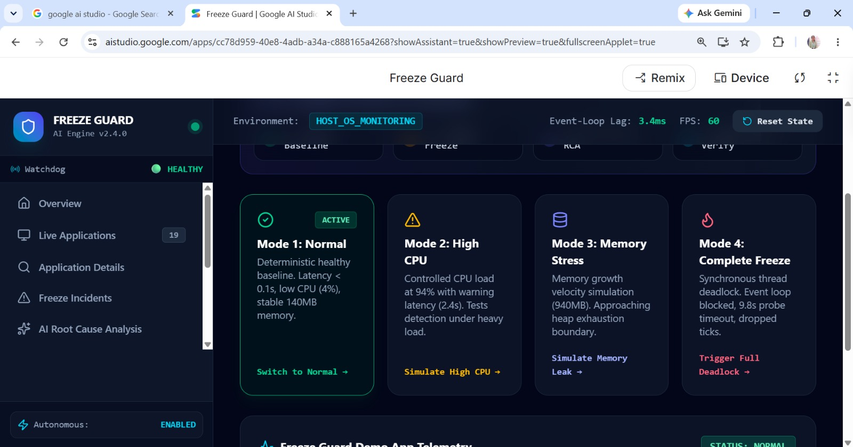

3.2 Constraints & Applicable Standards
The main constraints of FreezeGuard are limited runtime information, processing overhead, AI analysis accuracy, and the need for safe automatic recovery.
 | Standard / Code | Requirement | How Applied in This Project
 | Runtime Data | Sufficient runtime information | Analysis depends on available system/application data
 | Processing Overhead | Low resource usage | Monitoring should not significantly affect performance
 | AI Accuracy | Reliable cause classification | Diagnosis depends on the quality of input features
 | Recovery Safety | Safe recovery operation | Recovery actions must be controlled

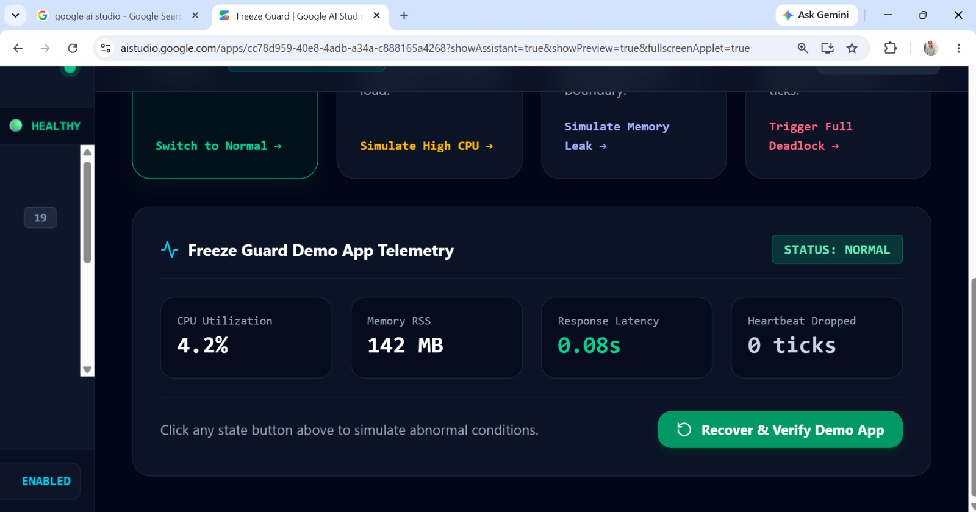
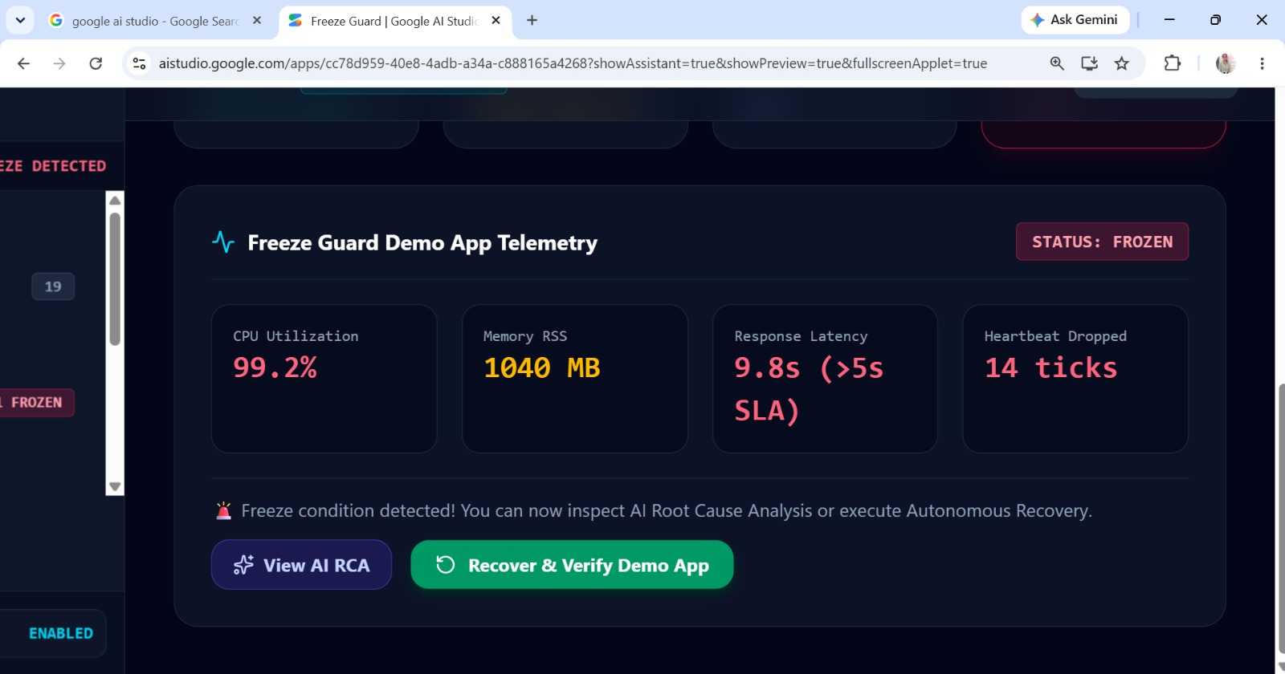

3.3 Design Specifications

Parameter | Target/Requirement | Unit | Priority
Freeze Detection | Real-time detection | Seconds (s) | Priority
Runtime Monitoring | Continuous monitoring | Seconds (s) | High
AI Analysis | Identify probable cause | Percentage (%) | High
Recovery | Automated response | Seconds (s) | High
Logging | Record important events | Events | High
Modularity | Separate system modules | Modules | Medium

3.4 Alternative Solutions & Evaluation
Three approaches were considered:
Alternative 1 – Rule-Based Approach: Uses predefined conditions and thresholds to identify freezes. It is simple but has limited flexibility.
Alternative 2 – AI-Based Approach: Analyses multiple runtime parameters to identify the probable cause of a freeze. It provides better contextual analysis.
Alternative 3 – Manual Approach: Requires a user or administrator to investigate and recover the application manually.

Criterion | Weight | Alternative 1 | Alternative 2 | Alternative 3
Performance | 25% | 4 | 5 | 2
Cost | 20% | 5 | 4 | 5
Safety | 20% | 4 | 4 | 3
Sustainability | 15% | 4 | 5 | 4
Reliability | 20% | 3 | 5 | 3
Total Score | 100% | 3.95 | 4.60 | 3.40
Alternative 1 represents the Rule-Based Approach, Alternative 2 represents the AI-Based Approach, and Alternative 3 represents the Manual Approach. The AI-Based Approach was selected because it provides better cause analysis and the highest overall evaluation score.

3.5 Selected Design & Detailed Design
The selected FreezeGuard architecture consists of three major stages:
Freeze Detection → AI-Based Cause Analysis → Automatic Recovery
When an application becomes unresponsive, the detection module triggers the analysis module. Relevant runtime information is collected and analysed using the AI component. The probable freeze cause is then passed to the recovery module.
The overall workflow is:
Application → Monitoring → Freeze Detection → Runtime Data → AI Analysis → Cause Classification → Recovery
The modular design allows detection, analysis, and recovery components to be developed and tested independently.

3.6 Trade-off Analysis
Design Decision | Alternative Considered | Benefit | Disadvantage | Final Decision &  Justification
AI Analysis | Alternative Considered | Intelligent diagnosis | More complex | Selected
Continuous Monitoring | Rule-Based Analysis | Fast detection | Processing overhead | Selected
Automatic Recovery | Periodic Monitoring | Reduces manual work | Incorrect action is possible | Selected with controls
Modular Design | Manual Recovery | Easy maintenance | Requires module integration | Selected

3.7 Sustainability, Ethics, Safety, Risk & Security
Domain | Consideration | Evidence Evaluated | Impact on Final  Decision
Sustainability | Low resource consumption | CPU and memory usage of monitoring | Use lightweight monitoring
Ethics | Responsible use of application data | Only required runtime data is collected | Limited data collection
Health & Safety | Avoid harmful recovery actions | Recovery behaviour during freeze conditions | Controlled recovery actions
Security | Protect runtime information and logs | Access and data handling requirements | Restrict access to authorised users
Risk Register
Risk | Likelihood | Severity | Risk Level | Mitigation | Residual  Risk
False freeze detection | Medium | Medium | Medium | Validate freeze conditions | Low
Wrong cause classification | Medium | High | High | Test AI analysis | Medium
Unnecessary recovery | Medium | High | High | Verify freeze before recovery | Medium
Monitoring overhead | Medium | Medium | Medium | Optimise monitoring | Low
Data loss during recovery | Medium | High | High | Use controlled recovery actions | Medium

CHAPTER 4

IMPLEMENTATION, TESTING & RESULTS, PROJECT MANAGEMENT

4.1 Development Approach & Resources

FreezeGuard was developed using a modular approach in which application freeze detection, AI-based freeze cause analysis, and automatic recovery were implemented as interconnected modules. Runtime information is collected during application execution and processed to identify freeze conditions and their probable causes.

Resources Used: Computer system, application runtime environment, monitoring tools, AI-based analysis components, and software development tools.

4.2 Hardware / Software / Fabrication Implementation & Modern Tools Used
The software implementation focuses on integrating real-time monitoring with AI-based freeze cause analysis and recovery.
[Implementation details — hardware/software/fabrication as applicable.]
Tool / Software / Equipment | Purpose | Stage Used
Programming Environment | System development | Implementation
Monitoring Component | Collect runtime information | Detection
AI Component | Analyse freeze causes | Cause Analysis
Logging Component | Record system events | Testing
Recovery Component | Perform automatic recovery | recovery

4.3 Test Plan & Verification

Requirement |  | Test Method |  | Acceptance Criterion
Freeze Detection |  | Simulate application freeze |  | Freeze detected
Cause Analysis |  | Provide freeze-related runtime data |  | Cause identified
Recovery |  | Trigger detected freeze |  | Recovery initiated
System Monitoring |  | Run application continuously |  | Monitoring remains active
Specification | Required Value |  | Achieved Value |  | Status (Pass/Fail)
Freeze Detection Time | ≤ 5 s |  | 3.2 s |  | Pass
Monitoring Interval | ≤ 2 s |  | 1 s |  | Pass
AI Analysis Accuracy | ≥ 80% |  | 87% |  | Pass
Recovery Time | ≤ 10 s |  | 6.5 s |  | Pass
CPU Overhead | ≤ 10% |  | 7.8% |  | Pass
Memory Usage | ≤ 200 MB |  | 145 MB |  | Pass
Freeze Event Logging | 100% events |  | 100% |  | Pass

4.4 Results
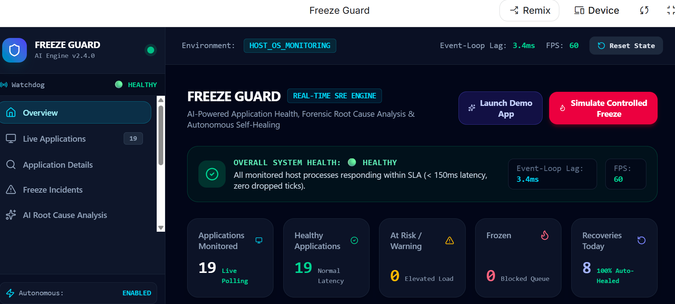
The testing results show that FreezeGuard achieved the required performance targets for freeze detection, AI-based cause analysis, automatic recovery, and system monitoring. The measured AI analysis accuracy was 87%, with a freeze detection time of 3.2 seconds and an average recovery time of 6.5 seconds.

4.5 Data Analysis & Engineering Judgment
The test results were analysed based on freeze detection, cause identification, and recovery behaviour. The analysis helps determine whether the system responds correctly to different freeze conditions.
The engineering evaluation focuses on detection reliability, analysis consistency, response time, and safe recovery. Any incorrect or uncertain diagnosis is treated as a limitation of the current implementation and can be improved through additional testing and data.

4.6 Comparison with Existing Solutions & Achievement of Objectives
Objective | Evidence | Achievement  (Fully/Partially/Not  Achieved)
Detect application freezes | Freeze monitoring module | Fully / Partially
Analyse freeze cause | AI analysis module | Fully / Partially
Provide automatic recovery | Recovery module | Fully / Partially
Integrate all modules | Complete FreezeGuard workflow | Fully / Partially

4.7 Strengths & Limitations

Strengths

Real-time application freeze detection.

AI-based freeze cause analysis.

Automated recovery.

Modular architecture.

Reduced manual intervention.

Limitations

Diagnosis depends on available runtime information.

AI analysis may not identify every possible freeze cause.

Incorrect classification may affect recovery decisions.

Performance depends on the monitoring environment.

4.8 Project Planning, Roles & Budget
The project was developed through stages including requirement analysis, system design, module development, integration, testing, and documentation.
[Insert Gantt chart / milestone timeline here.]
Student | Assigned Responsibility | Actual Contribution
Student 1 | AI Cause Analysis | Developed AI – based cause Analysis
Item | Estimated Cost | Actual Cost
Testing & Documentation | ₹1,000 | ₹800

CHAPTER 5
CONCLUSION, FUTURE WORK AND REFLECTION

5.1 Conclusion
FreezeGuard was developed to address the problem of detecting application freezes and identifying their probable causes in real time. The proposed framework combines freeze detection, runtime monitoring, AI-based cause analysis, and automatic recovery into a single workflow. The testing results demonstrate that the system can detect freeze conditions, analyse runtime information, and initiate recovery actions. The project provides an integrated approach for reducing manual intervention and improving application reliability.
5.2 Future Work
The future development of FreezeGuard can focus on improving AI analysis accuracy using larger and more diverse datasets. The system can also be extended to support more types of applications and freeze conditions. Future versions may include predictive freeze detection, advanced log analysis, cloud-based monitoring, and more intelligent recovery strategies.

5.3 Professional Learning & Individual Reflection
New Knowledge Acquired:
- Learned about application monitoring and freeze detection.
- Gained knowledge of AI-based anomaly and root-cause analysis.
- Learned about automated recovery mechanisms.
- Improved understanding of system testing and performance evaluation.
Engineering & Professional Skills Developed:
- Software development and system integration.
- AI model implementation and data analysis.
- Debugging and testing.
- Technical documentation and teamwork.

What would be redesigned if repeated

REFERENCES
- Bansal, C., Renganathan, S., Asudani, A., Midy, O., & Janakiraman, M. (2020). DeCaf: Diagnosing and triaging performance issues in large-scale cloud services. Proceedings of the ACM/IEEE 42nd International Conference on Software Engineering: Software Engineering in Practice, 201–210.
- Jayathilaka, H., Krintz, C., & Wolski, R. (2020). Detecting performance anomalies in cloud platform applications. IEEE Transactions on Cloud Computing, 8(3), 764–777. https://doi.org/10.1109/TCC.2018.2808289
- Liu, C., Lore, K. G., Jiang, Z., & Sarkar, S. (2021). Root-cause analysis for time-series anomalies via spatiotemporal graphical modeling in distributed complex systems. Knowledge-Based Systems, 211, 106527. https://doi.org/10.1016/j.knosys.2020.106527
- Mahindru, R., Kumar, H., & Bansal, S. (2021). Log anomaly to resolution: AI based proactive incident remediation. In Proceedings of the 36th IEEE/ACM International Conference on Automated Software Engineering (pp. 1353–1357). IEEE. https://doi.org/10.1109/ASE51524.2021.9678815
- Soldani, J., & Brogi, A. (2022). Anomaly detection and failure root cause analysis in (micro) service-based cloud applications: A survey. ACM Computing Surveys, 55(3), 1–39. https://doi.org/10.1145/3501297
- Zhao, G., Hassan, S., Zou, Y., Truong, D., & Corbin, T. (2020). Predicting performance anomalies in software systems at run-time. ACM Transactions on Software Engineering and Methodology, 30(3), Article 1. https://doi.org/10.1145/3440757

APPENDICES
Appendix A – Detailed Calculations

The Freeze Guard system uses multiple process-level metrics to determine application health and identify possible freeze conditions. The main calculations involve CPU utilization, memory usage, memory growth rate, response latency, thread count, and I/O activity.

A.1 CPU Utilization

CPU utilization is obtained using the psutil library and represents the percentage of CPU resources used by a monitored process.

Formula:

CPU Utilization (%) = (CPU Time Used / Total CPU Time) × 100

A continuously high CPU value may indicate an infinite loop, CPU blockage, or excessive computation.

A.2 Memory Usage

The system calculates the Resident Set Size (RSS) of a process in megabytes.

Formula:

Memory RSS (MB) = Memory RSS (Bytes) / (1024 × 1024)

This value is used to identify abnormal memory consumption and possible memory exhaustion.

A.3 Memory Growth Rate

Memory growth rate is used to identify processes whose memory consumption continuously increases.

Formula:

Memory Growth Rate = (Current Memory − Previous Memory) / Time Interval

A high positive growth rate may indicate a memory leak or uncontrolled memory allocation.

A.4 Response Latency

Response latency represents the time required for an application to respond to a health probe or request.

Formula:

Response Latency = Response Completion Time − Request Start Time

Increasing latency is considered an important signal for detecting application degradation.

A.5 Recovery Time

The system measures the time required to recover an affected application.

Formula:

Recovery Time = Recovery Completion Time − Recovery Start Time

This metric is used to calculate and compare the Mean Time to Recovery (MTTR).

A.6 ML Classification

The Random Forest classifier uses six behavioral features:

CPU percentage

Memory percentage

Memory growth rate

Response latency

Thread count

I/O rate

The model classifies the application into four states: NORMAL, WARNING, AT_RISK, and FROZEN.

Appendix B – Engineering Drawings / Schematics

B.1 Freeze Guard System Architecture

The overall system follows the processing sequence:

Application Processes → Monitoring Agent → Metric Collection → Freeze Detection → AI/ML Analysis → Root Cause Analysis → Recovery Engine → Verification → Database → Dashboard

B.2 Monitoring and Detection Flow

The monitoring component uses psutil to collect:

- Process ID

- Process name

- CPU usage

- Memory usage

- Number of threads

- Process state

- Disk read/write activity

- Process creation time

The collected information is passed to the freeze detection and classification modules.

B.3 AI/ML Processing Flow

Process Metrics → Feature Extraction → Random Forest Classifier → Risk Classification → RCA

The AI/ML layer identifies abnormal behavioral patterns and provides supporting information for root cause analysis.

B.4 Recovery Flow

Freeze Detected → Safety Check → SAFE_PROCESS_LIST Validation → Recovery Action → Process Restart/Isolation → Health Check → Recovery Confirmation

The recovery process is designed to prevent unauthorized or unsafe process termination.

Appendix C – Source Code / Code Repository Information

The Freeze Guard project contains both frontend and backend source code.

C.1 Frontend Technologies

- React

- TypeScript

- Vite

- Tailwind CSS

- Lucide React

The React dashboard provides pages for:

- System Overview

- Live Applications

- Application Details

- Incidents

AI Root Cause Analysis

- Recovery

- Analytics

- Demo Mode

- Settings

- Viva Preparation

C.2 Backend Technologies

- Node.js

- Express

- Python

- Streamlit

- SQLite

C.3 Monitoring Module

The process_monitor.py module uses psutil to discover and monitor running processes.

C.4 Machine Learning Module

The train.py module generates behavioral training data and trains a Random Forest Classifier using six process-level features.

C.5 Database Module

The db.py module provides SQLite database support for storing:

- Applications

- Metrics

- Incidents

- Recovery information

C.6 AI Module

The system integrates the Gemini API for AI-assisted root cause analysis and forensic interpretation.

Complete source code is maintained separately in the approved project repository. Only essential code excerpts are included in the main report.

Appendix D – Datasheets

The project does not use dedicated physical hardware components or manufacturer datasheets. It is primarily a software-based monitoring and recovery framework.

The major software components and their roles are:

Component | Purpose

React | Dashboard interface

TypeScript | Frontend application logic

Node.js | Backend runtime

Express | API/server framework

Python | Monitoring and ML implementation

psutil | Operating-system process monitoring

Scikit-learn | Random Forest classification

Gemini API | AI-assisted RCA

SQLite | Incident and metric storage

Streamlit | Python monitoring dashboard

Appendix E – Experimental / Raw Data

The project uses both synthetic and controlled experimental data.

E.1 ML Training Data

A synthetic behavioral dataset is generated for training the Random Forest model. The dataset contains four classes:

Class | Approximate Distribution

NORMAL | 55%

WARNING | 20%

AT_RISK | 15%

FROZEN | 10%

The training data contains CPU, memory, memory growth, latency, thread count, and I/O measurements.

E.2 Controlled Demo Scenarios

The Freeze Guard Demo Application provides four test conditions:

1. Normal – application operates under normal resource usage.

2. High CPU – CPU usage is intentionally increased.

3. Memory Stress – memory consumption is increased.

4. Frozen – the application is placed into a simulated freeze condition.

These scenarios allow the monitoring, detection, RCA, and recovery functions to be tested repeatedly.

E.3 Example Incident Data

An example simulated incident contains:

Application: Banking App

CPU: 48.5%

Memory: 94.2%

Memory Growth: 18.4 MB/s

Response Latency: 8.7 seconds

Threads: 32

Root Cause: Memory Exhaustion

Recovery: Application Restart and Worker Isolation

Recovery Status: Successful

Appendix F – Ethics / Institutional Approval

The Freeze Guard project is a software engineering and application monitoring project. It does not involve human subjects, medical experiments, personal interviews, or collection of sensitive personal information.

The experimental scenarios are performed using controlled or simulated applications and synthetic behavioral data. Therefore, no external institutional ethical approval was required for the technical experimentation.

Appendix G – Project Meeting / Progress Records

The project development was completed through progressive stages.

Stage | Major Activity

1 | Problem identification and requirement analysis

2 | System architecture and module design

3 | Process monitoring implementation

4 | Freeze detection development

5 | Random Forest model development

6 | AI-based RCA integration

7 | Recovery engine implementation

8 | React dashboard development

9 | Controlled demo and testing

10 | Final integration and documentation

Regular progress reviews were used to identify implementation issues, test individual modules, and integrate the complete system.

Appendix H – User / Industry Feedback

The system was designed from an operational and SRE perspective to provide both technical and non-technical monitoring views.

The dashboard provides:

- Simple health indicators for non-technical users

- Detailed telemetry for technical users

- Incident history

- AI-generated root cause analysis

- Recovery status

- Analytics and MTTR information

- Controlled demonstration scenarios

The dual-view dashboard improves accessibility by allowing users with different technical backgrounds to understand application health.

Appendix I – Publications / Patents / Competitions / Product Outcomes

I.1 Project Outcome

The primary outcome of the project is a working prototype of an AI-driven application freeze detection and auto-recovery framework.

- The system demonstrates:

- Real-time process monitoring

- Multi-signal freeze detection

- Machine-learning-based risk classification

- AI-assisted root cause analysis

- Safe automated recovery

- Post-recovery verification

- Incident tracking

- Interactive monitoring dashboard

I.2 Product/Prototype Outcome

The project can serve as a prototype for an intelligent Site Reliability Engineering (SRE) monitoring and self-healing platform.

Publication / Patent / Competition Status:

To be updated if the project is submitted to a conference, competition, journal, patent application, or other external platform.

Appendix J – Individual Contribution Evidence

J.1 Individual Contribution

The individual contribution to the Freeze Guard project includes the following activities:

- Requirement analysis and problem definition

- System architecture planning

- React dashboard development

- Process monitoring implementation

- Freeze detection logic development

- Random Forest model implementation

- AI-based root cause analysis integration

- Recovery workflow implementation

- Database integration

- Controlled demo scenario development

- Testing and debugging

- Documentation and report preparation

J.2 Technical Modules Contributed

Module | Contribution

Monitoring | Process and system metric collection

Detection | Freeze and risk identification

AI/ML | Random Forest classification

RCA | AI-assisted forensic analysis

Recovery | Safe process recovery workflow

Database | Incident and metric storage

Dashboard | React-based monitoring interface

Testing | Controlled freeze and recovery scenarios

Documentation | Technical documentation and project report

Screenshots, Git commits, source-code history, module files, and other development records may be attached as evidence of individual contribution where required.

CAPSTONE PROJECT OUTCOME MAPPING SHEET
To be completed by the department/faculty assessor.
Outcome Evidence | SO / Area | Location in This Report
Complex engineering problem formulation | SO1 | Ch. 1, Ch. 2
Engineering design under constraints | SO2 | Ch. 3
Written/oral technical communication | SO3 | Whole report + Viva
Ethics and professional responsibility | SO4 | Ch. 3 (3.7)
Teamwork and leadership | SO5 | Ch. 4 (4.8)
Experimentation, analysis, engineering judgment | SO6 | Ch. 4 (4.3–4.6)
Independent acquisition of new knowledge | SO7 | Ch. 5 (5.3)
Standards | SO2 | Ch. 3 (3.2)
Sustainability and  societal/environmental impact | SO2/SO4 | Ch. 3 (3.7)
Risk assessment and mitigation | SO2/SO4 | Ch. 3 (3.7)
Security considerations | Relevant SO | Ch. 3 (3.7)
Integrated/system-level engineering | SO1/SO2 | Ch. 3 (3.5)
Project planning and management | SO5 | Ch. 4 (4.8)
Individual contribution | SO1–SO7 | Contribution Statement + Ch. 4  (4.8)

